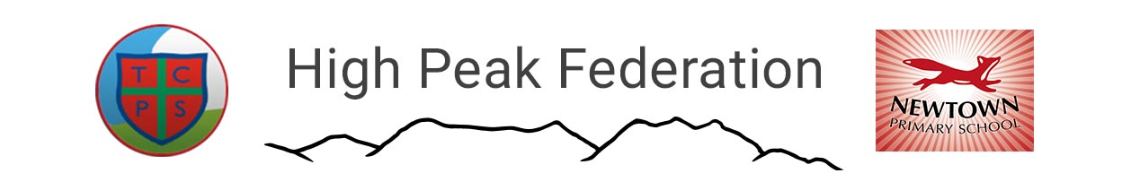

Executive Head Teacher – Mr Ashley Parry

Thornsett Primary School Newtown Primary School

Aspenshaw Road Buxton Road

Birch Vale New Mills

High Peak High Peak

SK22 1AT SK22 3JS

01663 744391 01663 744358

info@thornsett.derbyshire.sch.uk info@newtown.derbyshire.sch.uk

www.thornsett.derbyshire.sch.uk www.newtownprimary.org.uk

2.5.24

Newtown Ofsted Report

We can now share the Ofsted report from our recent inspection.

Although final reports under the new framework are much less detailed, we are pleased that the report captures much of the excellent practice in place at Newtown. Pages 2 and 3 summarises what the inspectors experienced during the two days. The inspection was very thorough too, with pages 5 and 6 of the report detailing how the inspectors gathered their evidence. This is important, as it reinforces that the inspectors’ judgements are based on analysing multiple lesson visits, playtime and lunchtime observations, discussions with staff, parents, and the large majority of pupils, governors and DCC advisors, as well as book and planning scrutiny over the two days.

The grading of ‘good’ in all areas should be reassuring for the school community. The grading system is based on single words and although we did not achieve an ‘outstanding’ grade (under the new framework very few school do), it is right to say that we were a ‘good good’ and did demonstrate many examples of outstanding practice, even if not enough for that grade to be awarded.

The inspection process always identifies a couple of areas where we can further improve and we have already put in place actions as a result.

The first is that in a small number of subjects, the work given to pupils is not challenging enough. This is in response to a Maths lesson being observed where the main learning for the lesson was challenging, but there was not sufficiently challenging extension provided for when some of the children had finished. It also links to an Art lesson where it was felt more challenging vocabulary should have been included in the planning, to build on the previous learning. Both these areas have already been addressed.

The second is that the children did not have a secure understanding of British Values, including tolerance and democracy and suggests they are not fully prepared for life in modern Britain, as a result. In discussions with children, they could share how in assembles and PSHE lessons they discussed British Values, but struggled to use terms linked to British Values such as individual liberty, the rule of law, democracy and mutual respect. We have made a point of reinforcing these important values since the inspection. Paragraph 4 on page 3 of the report captures many examples of how we do prepare children very well for life in modern Britain, so being able to articulate the key terms linked to British Values is just one element that we need to address.

We will continue to provide the high quality of education provision that the report details, as well as pushing on with new initiatives to improve too. Implementing even more effective feedback to children about their next steps, developing further creativity in teaching and providing staff with continued professional development in key areas of teaching pedagogy are our current priorities and the inspection team agreed these were sound choices too.

Wishing everyone a slightly longer weekend.

Mr Parry and the High Peak Federation team

